EX NO: 3 | Configure DNS and DHCP protocols using Packet Tracer
DATE:25/07/26

Objectives:
- To configure and verify the DHCP protocol for automatic IP address allocation to client devices in a network.
- To configure and test the DNS protocol for translating domain names into IP addresses and enabling access to network resources using hostnames.

Software/Apparatus required:
  - Cisco Packet Tracer
  - End Devices (PCs)
  - Switches
  - Copper Straight-through Cable / Automatic Cable Selector
  - Routers
  - Server (DNS, HTTP and DHCP)

Procedure:
Objective 1: DHCP protocol
    - Create the required network topology using switches, a server, and PCs.
    - Connect all devices using appropriate network cables.
    - Open the server and enable the DHCP service.
    - Create a DHCP pool and specify the network parameters.
    - Configure the server with a static network address.
    - Open each PC and select DHCP in the IP Configuration settings.
    - Verify that the PCs automatically receive network configuration from the DHCP server.
    - Test communication between the PCs and the server using the ping command.
    - Save the Packet Tracer project.

Objective 2: DNS protocol

      - Create the network topology using PCs, switches, a router, a DNS server, and a web server.
      - Connect all devices using appropriate network cables.
      - Configure the router interfaces and enable communication between the networks.
      - Assign network addresses to all PCs, servers, and router interfaces.
      - Open the DNS server and enable the DNS service.
      - Create DNS records to map domain names to the web server.
      - Open the web server and enable the HTTP service.
      - Create and save the required web pages on the web server.
      - Configure the PCs with the DNS server address.
      - Open a web browser on any PC and access the website using the configured domain name.
      - Verify that the webpage is displayed correctly and test connectivity using the ping command.
      - Save the Packet Tracer project.

Diagram
Objective 1: DHCP protocol

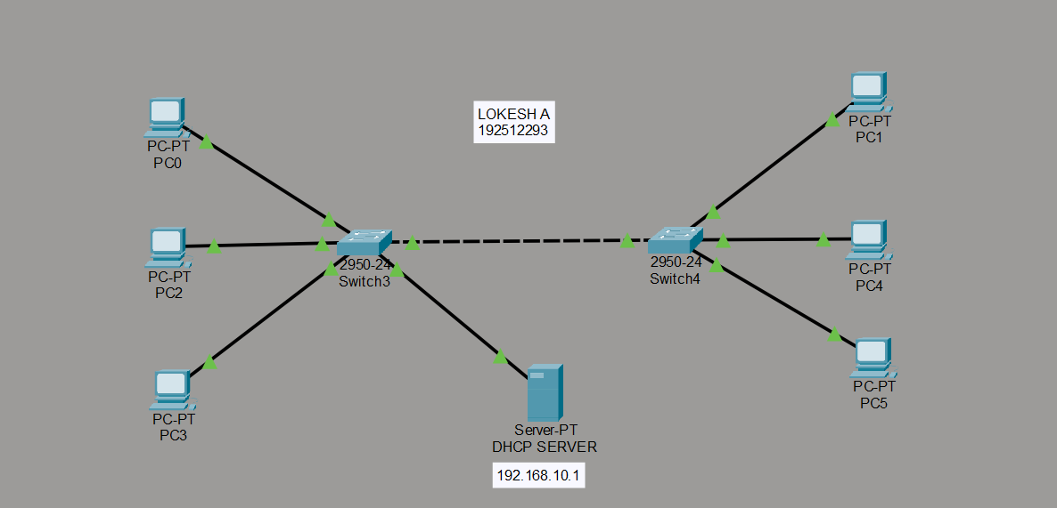

Objective 2: DNS protocol
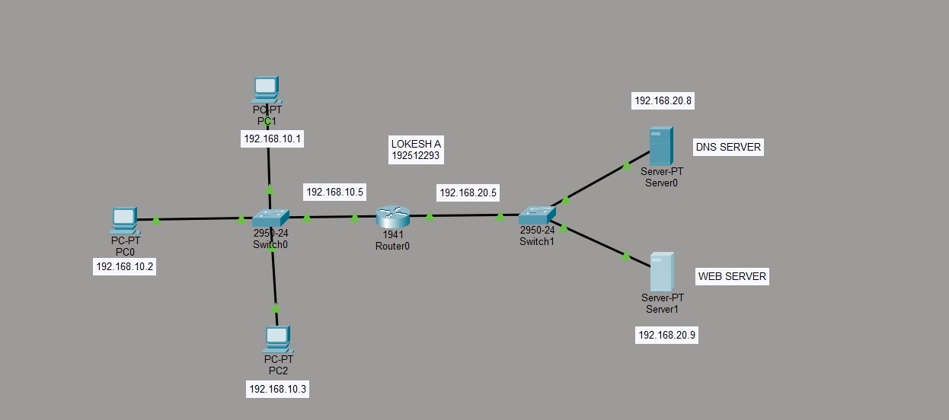

Output:
Objective 1: DHCP protocol

SI.  No | Source IP | Destination IP | Data sent (bytes) | Data received (bytes)
1. | 192.168.10.1 | 192.168.10.2 | 4 | 4
2. | 192.168.10.2 | 192.168.10.3 | 4 | 4
3. | 192.168.10.3 | 192.168.10.4 | 4 | 4
4. | 192.168.10.4 | 192.168.10.5 | 4 | 4

Objective 2: DNS protocol
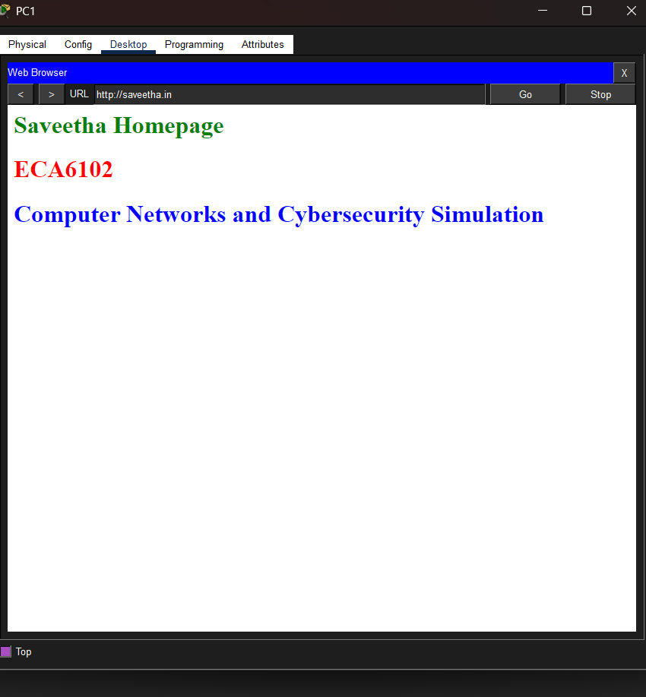

Results
Objective 1: DHCP Protocol
- The DHCP protocol was successfully configured, and the client devices automatically obtained network configuration parameters from the DHCP server.
Objective 2: DNS Protocol
- The DNS protocol was successfully configured, and the configured domain names were successfully resolved to access the web server using hostnames.

Test case 1 Question:
Implement the specified DNS and Web Server topology using Cisco Packet Tracer and analyze domain name resolution and webpage accessibility.

Case 1
  - Number of PCs: 3
  - Number of Switches: 1
  - Number of Routers: 1
  - Number of DNS Servers: 1
  - Number of Web Servers: 1
  - Number of DNS Records: 2

Case 2
  - Number of PCs: 5
  - Number of Switches: 2
  - Number of Routers: 1
  - Number of DNS Servers: 1
  - Number of Web Servers: 1
  - Number of DNS Records: 4

Tasks
- Construct the specified topology and configure the router, DNS server, and Web server.
- Create the required DNS records and host web pages on the Web server.
- Configure the client PCs and verify domain name resolution and webpage access using hostnames.
Aim (10) | Networking Diagram  (30) | Procedure (10) | Results (20) | Record (10) | Viva (20) | Total (100)

Test case-2 Question

Implement the specified DHCP topology using Cisco Packet Tracer and analyze automatic IP address allocation to client devices.

Case 1
  - Number of PCs: 4
  - Number of Switches: 1
  - Number of DHCP Servers: 1
  - IP Assignment Method: Dynamic

Case 2
  - Number of PCs: 6
  - Number of Switches: 2
  - Number of DHCP Servers: 1
  - IP Assignment Method: Dynamic
  - Inter-switch Connection: Switch-to-Switch Link

Tasks
- Construct the specified topology and configure the DHCP server with the required address pool.
- Configure all PCs to obtain network settings automatically from the DHCP server.
- Verify IP address allocation and analyze connectivity among the client devices.

Aim (10) | Networking Diagram  (30) | Procedure (10) | Results (20) | Record (10) | Viva (20) | Total (100)

